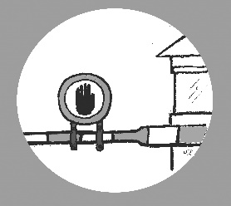
Call for Action
Stop the Sex Work Regulation Act!

Dear customer,
The Dutch government has proposed a law that is bad for sex workers and their clients, the Sex Work Regulation Act (WRS). The proposal is bad because it criminalizes sex workers and their clients. It requires sex workers to apply for a permit, and to be included in a national register. If the sex worker you are visiting does not have a license, you run the risk of a one-year imprisonment. You will have to check the register yourself to see if the sex worker you are visiting has a license. The sex worker risks a fine of €20,750. And people who help sex workers without a license risk 2 years in prison.
The government's goal with this law is to combat human trafficking and violence against sex workers. Of course, as a client, you do not want to visit a sex worker who is a victim of that kind of abuse! And of course sex workers do not want to become victims. But sex workers, health workers and other professionals think that this law will only aggravate the problems of human trafficking and violence. Why? Because more sex workers will have to work illegally, without a license since:
- They are not yet 21 years old
- They don’t have a permit to work in the Netherlands
- Civil servants do not deem them sufficiently 'self-reliant'
Many sex workers will not be able to meet these requirements and will therefore be forced to work without a license. Others will choose to work without a license because they are concerned about the security of the information in the register. As a client, you also know that sex workers who work illegally are much more at risk of becoming victims of human trafficking and violence. You do not want to use the services of a sex worker who is a victim. You want to help that sex worker. But you cannot because if you report an abuse to the police, you run the risk of being imprisoned. After all, you have used the services of a sex worker without a license.
Therefor it is time for action. It is important for you as a client, and for sex workers, that this proposed bill is retracted. That is why we ask you to respond to the internet consultation for this law. We have made a sample letter that you can send to the consultation. Of course you can also send your own reaction.
Take action! Thank you in advance for your support.
You can respond until 15 December via this website: https://www.internetconsultatie.nl/sekswerk

