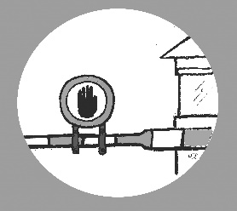
CALL FOR ACTION
Stop the Sex Work Regulation Act!

Dear Sex Worker,
The Dutch government has proposed a law that is bad for sex workers (Bill on the regulation of sex work, shortened as Wrs). The proposal is bad because it criminalises sex work. It requires sex workers to apply for a license and to be included in a national register. If you work without a licence, you run the risk of a fine of € 20,750. Your client risks a one-year prison sentence. And people who help you risk 2 years imprisonment.
Well, why not just apply for a permit than, you would say. That is too easy a thought. You don't get a permit just like that because:
- You must be at least 21 years old
- You must be allowed to work in the Netherlands
- Civil servants have to find you suitable to do sex work...
Many sex workers will not meet these requirements. The first two are clear. But how are these civil servants going to determine whether you are ‘suitable’? This is about whether you speak the language sufficiently, but also about whether you are sufficiently resilient in their opinion to stand up for yourself. If they suspect coercion or abuse, you will not receive a permit either. More than enough reasons not to grant a licence to a large number of sex workers. And that means that you end up in illegality if you want to work.
There are also major objections to the national register. They record all kinds of things about you. Not only your name and BSN number, but also information from the conversation the officials have with you. This increases the risk of your personal information becoming public. That's not what you're looking for. This is private information that can work against you in all kinds of situations. Such as when you are looking for a job. Or a house. Or when your children find out. Many sex workers will therefore not want to register and will work illegally.
Illegal sex workers are much more likely to become victims of violence and abuse. This law will push more sex workers into illegality. Exactly the opposite of what the government says it wants to achieve.
So, it's time to act! Attached is an example letter that you can send to the government to make your voice heard against this proposed law. It is important that as many sex workers as possible make themselves heard! That the government gets the message that this law is a very bad idea. And that the law is retracted.
Come into action!
You can react until December 15! You can do this by clicking on the button 'Give your reaction to this consultation' on this website: https://www.internetconsultatie.nl/sekswerk
You can also use the sample letter and attach it as a document.

